Design and First Implementation of Business Process Visualization for a Task Manager supporting the Workflow in an Operating Room
E. Fink¹, M. Wiemuth¹, O. Burgert¹

¹Reutlingen University, School of Informatics, Research Group Computer Assisted Medicine (CaMed) Reutlingen, Germany
Contact: elena.fink@student.reutlingen-university.de, {markus.wiemuth, oliver.burgert}@reutlingen-university.de

Abstract
An operating room is a stressful work environment. Nevertheless, all involved persons have to work safely as there is no space for mistakes. To ensure a high level of concentration and seamless interaction, all involved persons have to know their own tasks and the tasks of their colleagues. The entire team must work synchronously at all times. To optimize the overall workflow, a task manager supporting the team was developed.
In parallel, a common conceptual design of a business process visualization was developed, which makes all relevant information accessible in real-time during a surgery. In this context an overview of all processes in the operating room was created and different concepts for the graphical representation of these user-dependent processes were developed.
This paper describes the concept of the task manager as well as the general concept in the field of surgery.
Keywords: task manager, surgical workflow, business process visualization, integrated operating room

Purpose
Working in an operating room (OR) is noisy, expensive and stressful. One minute of using an OR costs about 12 Euro [1]. There are often shortcomings in the process quality concerning the organization in the OR, e.g. the scheduling is unreliable or patients have to wait for hours in front of the OR. Reasons may be e.g. the lack of communication, break-times, absence of the surgeon, emergencies, insufficient coordination of processes.
In order to improve this situation, all team members in the OR have to be very concentrated and have to synchronize their work pre-, intra- and post-operatively. Therefore, communication of individual progress to other team members plays a crucial role to avoid waiting times or potentially dangerous situations.
This is especially challenging due to the high variability of individual patient properties, surgical capability or the different technologies in an OR, tasks or workflows can be totally different for different types of surgery. Also, for the same reason, the actors participating can vary.
In other domains, workflow management systems support the personal in performing complex and interleaved processes. E.g. in aviation, checklist driven approaches have helped to reduce risks and stress [2] [3]. We assume, that some of the techniques used in other industries can be implemented in the OR as well, but the unique challenges of the OR situation must be considered. We believe, the process and its activities must be displayed to all team members in a personalized manner in order to provide maximum security and process compliance. Unfortunately, the high variability described above makes the development of a standard visualization concept quiet complex compared to the visualization of business processes.
Methods
To support the team in the OR, a task manager was designed and implemented. The task manager shall support the whole team in the OR and give the actors in and outside the OR an overview of the state of every involved actor. We assume the process to be already sub-divided into tasks, which can either be executed in sequential order or being skipped by each actor. The concept of workflow managers in the OR was used to design the task manager [4] [5] [6]. Every actor gets their own client terminal to interact with the system. Also, a central screen, which shows an overview of all tasks, is placed in the OR. The system is designed as a distributed system with a master node (server) and different client terminals. The task manager server is running on a computer with the operating system Microsoft Windows 7. The client terminals can run on different devices and operating systems such as smartphones and tablets with Android or Windows or other devices running Linux. The system uses the Open Surgical Communication Bus [7] and the STORZ Communication Bus (KARL STORZ–SCB®) as infrastructure [8]. The first version of the task manager used a scrum board approach for visualizing the tasks.
After the implementation of the first prototype for the task manager, a visualization system was developed with the aim to extend the capabilities and usability of the task manager. Before the visualization concept was designed, the actual situation in operating rooms and the activities of the involved persons were analyzed and categorized. After that, different concepts were developed for a surgeon, for an anesthesiologist, for a nurse, a circulating nurse, for the cleaning team, for the operating room manager and others.
The basis for the design of the first concepts were a hypothetical interaction scenario – a navigated spine surgery in a hybrid operating room – as well as the process/workflow -modeling which has been described in [9]. Based on that and on interviews conducted with medical, informatics, and human interaction experts, a summary of requirements was created. In consideration of these requirements and of different rules of design, different concepts were developed and applied to every user group.
It was important for the implementation to consider potential acceptance issues with the operating team, which already do many tasks on a routine basis. In order to facilitate the acceptance, existing milestones in the operating process which already need to be documented (e.g. “time of insertion”, see [10]) were selected as the basis for the concept and the visualization of the different steps and phases. However, a detailed analysis of the operating processes yielded that these already existing milestones are in fact the only standardized fixed points which are valid for all different operating scenarios.
Results
A master node (the server) was implemented without a user interface, since the main task of the master node is to receive and transmit all messages between the client terminals. A big screen, the task board, shows an overview of all tasks of all actors in the OR. Different client terminals, depending on the user’s needs, were developed: A Raspberry Pi system was connected to a footswitch which allows the surgeon to interact with the task manager by foot and to have free hands during the surgery. The scrub nurse can get a stationary client in her working area. The circulating nurse can get a tablet or smartphone that can be taken to any location. All client terminals can send the user inputs directly to the task manager server and are able to display the changes of all tasks except the footswitch. The footswitch can only be used as an input device without visualization.
Up until now, the system has been successfully tested in a laboratory environment based on the tasks occurring in a real surgical intervention. The chosen intervention is a laparoscopic cholecystectomy. The tasks for the intervention where taken from [11].
After the first technical evaluation, various concepts for the visualization of different OP-processes were developed. As a first step, a concept for a general overview of the different tasks was designed, based on [12]. It is intended to be an extension of the task manager described above. To this concept, another important aspect was added: the time aspect, in the form of a timeline and clock-shaped progress icons. This way the focus is shifted to both the duration of the individual tasks as well as the duration of the overall process. By following the general rules of design for information visualization (e.g. aggregation and reduction, consistency, [13]) and by using intuitive symbols and graphical representations the modeled process should be clear and comprehensible, so that users who are no professionals in the IT-field can read and understand the included information without problems.
As indicated below an interactive process was used to implement a basic concept for the visualization of all user specific information. Depending on the user needs, the views and their details can change during the intervention, see Figure 1. For example, the OR-Manager (indicated in blue) needs an overview over all OR’s and information about the interventions proceeded.
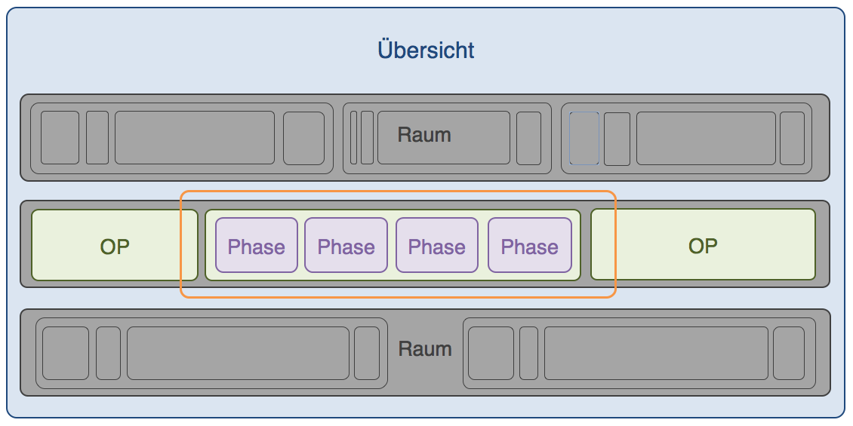
Figure 1: level of detail during the intervention
The surgeon (indicated in orange) needs a detailed view with all information for the intervention and the systems they use. Furthermore, he needs information about the phases and steps of the intervention.
For the conceptual visualization of the OR’s overview the basic elements of a “Scrum Board” where used [8] and the visualization where made, following the “mediawide” concept.
Figure 2 showing the „General Operating Room Overview“ visualization screen. The individual tasks are aligned vertically by different users and are grouped horizontally by individual phases. For example, the beige phase indicates the phase between first cut and final stitching of the wound. Each phase can be drawn collapsed if it is unimportant at a certain point in time.
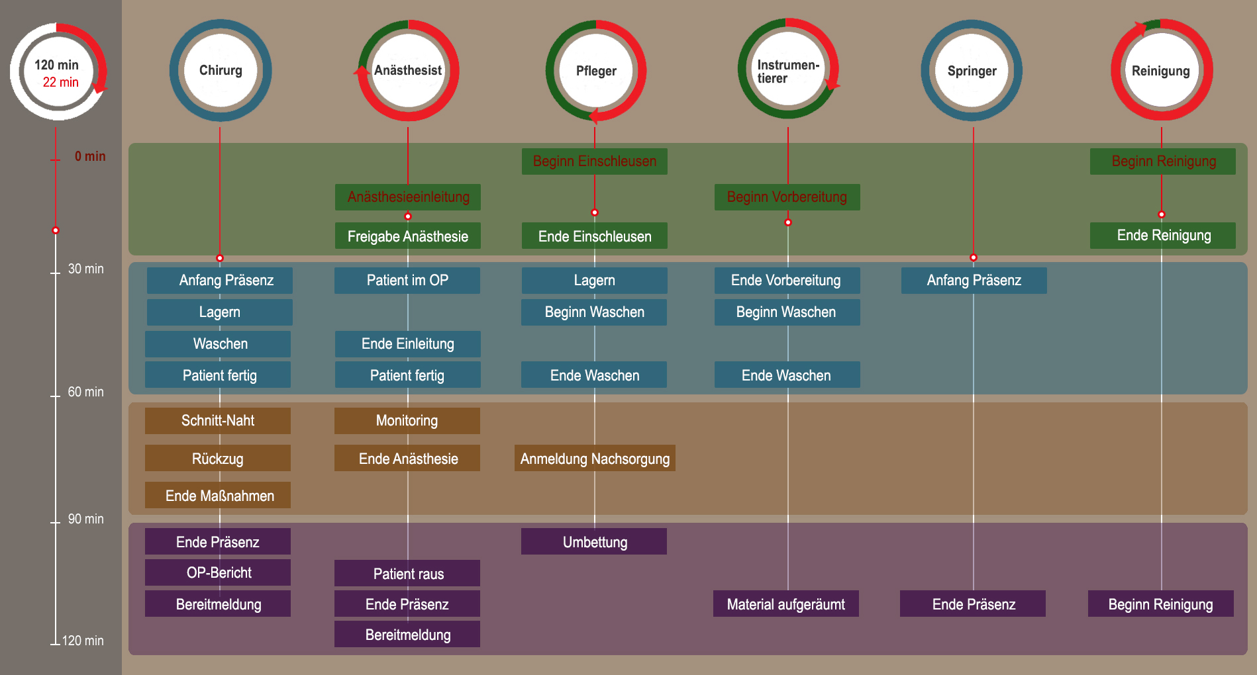
Figure 2: Business Process Visualization – Operating Room Overview
In the context of user-specific processes, another visualization concept has been used to ensure detailed perspectives of the individual tasks/ phases. Such individual interfaces, which only display user-dependent information, were designed for any person involved in the process. As an example, Figure 3 shows the user-specific interface for a nurse.
The area marked in blue (No.1) gives an overview of general information relevant to the ongoing surgery, such as data of patients, list of team members, etc. This information field is optional and can be hidden or shown as required.
The area marked in green (No.2) informs the user about tasks of other users which depend on their own tasks. This way, the user is able to see and understand their tasks in the overall context, which helps him to react quickly in case of unforeseen problems or emergencies. The information displayed in this area will vary according to the type of user and the current phase of the surgery.

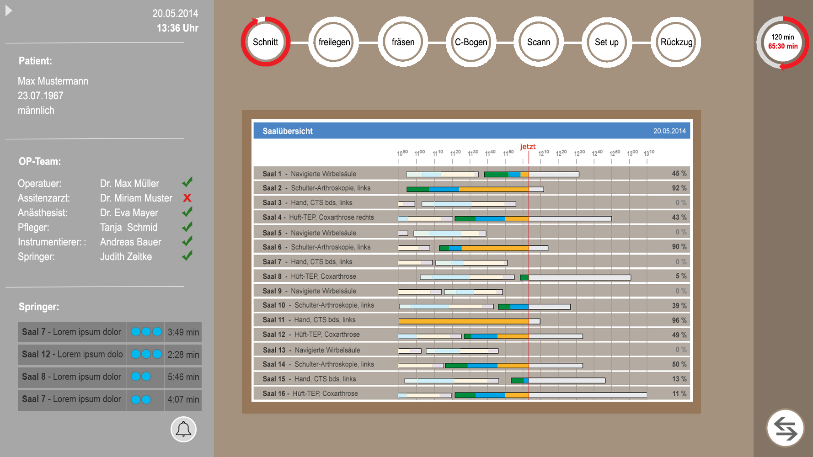
1
3
4
2
Figure 3: Business Process Visualization – Nurse User Interface
The area marked in orange (No.3) shows the user interface of the medical system which is used in the current phase of the surgery. For example, during the surgery, the surgeon can see live image of the 3D-Scan and the corresponding navigation display.
The area marked in red (No. 4) is used to display and interact with general settings and information. In the upper right-hand corner, the user can see both the scheduled and the actual time of the ongoing surgery. When the user clicks the button on the lower right-hand corner, he can switch to a settings menu which is separated into three sub-categories: Patient, OR personnel, Operating Room. Some of the settings which can be changed in this menu include: Operating table, light setting, Air-conditioning, etc.
The visualization for the OR-Manager and the housekeeper where made, using a kind of Gantt chart. The main benefit, using the Gantt chart, is the structured visualization of time sequences and their context. The implementation of the OR-Manager visualization is based on the visualization of MS Project. Like in MS Project, the user can manage and plan interventions, see the progress and is able to see deviations to the planned state. Conditions for such diagram are the start and end times of the processes (in this case the intervention) or rather the duration of all individually steps.
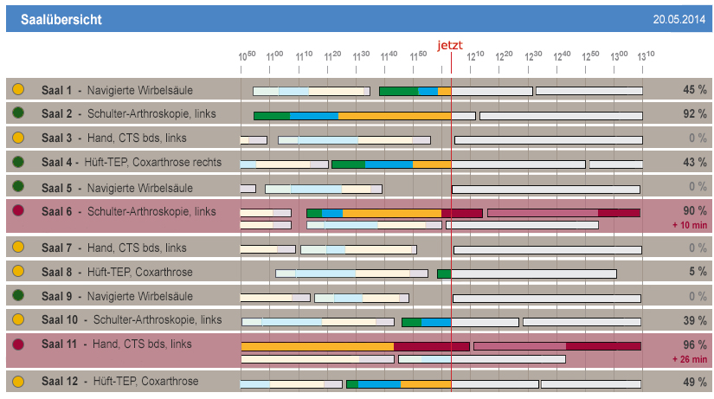
Figure 4. Visualization concept – OR-Manager/Housekeeper
The presentation of the OR-Manager/housekeeper was created following the concept in [14]. Furthermore, a traffic light metaphor was included to display the time state of each OR depending on the estimated and the real time (see Figure 4, circles left).
The meanings of the colours are as follows:
Green: The intervention is in time and seems to be finished in the estimated time.
Yellow: The intervention is in time, but probably will not be finished in the estimated time.
Red: The intervention is behind time and the next intervention causes a delay to the followed intervention. The delay in the next intervention is marked in red on the time line.
The visualization for the circulation nurse, which will be displayed on a tablet or smartphone, is based on the task manager concept from [8], see figure 5. The events or tasks, with highest priority or longest duration, are displayed on top of the list. The categorization is made by the principals or based on underlying clusters.
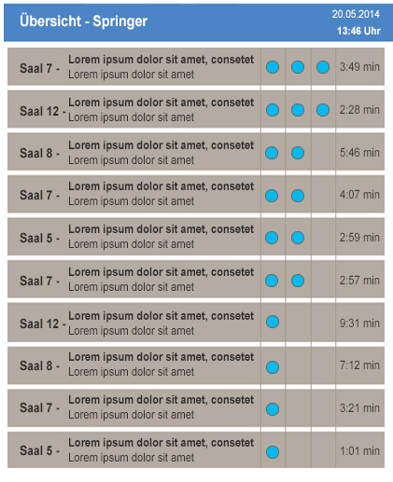
Figure 5. Visualization concept - circulation nurse
The time, accurate to the second, in the right column, indicates how long the task or event took. In principal, the order is based on the priority (3 dots = high, 2 dots = important, 1 dot = normal) and within the priority classes ordered by the times, from high to low. Other actors, like the surgeon, anesthetist or scrub nurse, get an overview of the task list from the circulation nurse, see figure 3. This was done to give them an overview over the work of the circulation nurse.
New or breakthrough work to be presented
The task manager is capable of supporting the whole team, not only one participant of the surgery, like the surgeon. The interaction scheme is simplified to allow real world implementations which do not overstrain the medical end users. It is one of the first systems which are integrated in an integrated OR infrastructure.
The complex processes in an operating room have been digitalized, catalogued and processed, both for the overall processes in an operating room as well as for the user-specific processes. A concept for a state of the art visualization system, which can display a lot of information out of different systems, has been developed. It is used to illustrate the complex processes of an operating room in an intuitive and easy-to-read graphical representation.

Conclusion
A task manager and a concept for the visualization of operating room processes, tasks and information have been created, allowing first real world tests of workflow guidance in the OR.
The visualization concept integrates certain crucial operating room information and presents it in a common, intuitive and easy-to-read user interface, thus supporting the operating team members in the complex and demanding process of a surgery. The system will above all support the users to instantly notice deviations from the planned schedule or potential delays and allow them to react quickly to these changes. This way, unnecessary waiting times and interferences with other ongoing tasks can be avoided, or, at least, reduced.
By implementing the prototype and visualization concepts, communication problems, as well as cost and risk factors, can theoretically be reduced in an operating room, potentially helping the clinic to save money and patient’s lives (increase patient’s safety).
However, in order to further evaluate the benefits of the developed concept, extensive observations, surveys and feedback from medical experts are desired. As a next step, a prototype for both the task manager and the visualization system should be implemented and tested during life surgeries. This would help to evaluate the full potential of the concepts described in this paper.
For user acceptance, it will be crucial to restrict the manual input needed to the absolute minimum – in the best case, the system will automatically detect the current state for each actor and change status automatically. There are several research groups working on this goal and we will incorporate those techniques as they become available.

References
- Bauer, Hartwig (2010): Cockpit und OP-Saal: Checklisten verbessern Sicherheit. Deutsche Gesellschaft für Chirurgie. http://www.dgch.de/fileadmin/media/texte_pdf/servicemeldungen/Sicherheitschecklist_Artikel_Bauer.pdf , (last access: 08.10.2013)
- Kohn, Linda T.; Corrigan, Janet; Donaldson, Molla S. (2000): To err is human. Building a safer health system. Washington, D.C: National Academy Press (Quality chasm series).
- Rall, M.; Lackner, C. K. (2010): Crisis Resource Management (CRM). In: Notfall Rettungsmed 13 (5), S. 349–356. DOI: 10.1007/s10049-009-1271-5.
- Thomas Neumuth (2012): Surgical Process Modeling. - Theory, Methods, and Applications -. Habilitation thesis, Leipzig. http://www.iccas.de/wp-content/uploads/2012/12/Neumuth-Surgical-Process-Modeling.pdf, last access: 09.10.2013.
- Forestier, Germain; Lalys, Florent; Riffaud, Laurent; Louis Collins, D.; Meixensberger, Jurgen; Wassef, Shafik N. et al. (2013): Multi-site study of surgical practice in neurosurgery based on surgical process models. In: Journal of Biomedical Informatics. DOI: 10.1016/j.jbi.2013.06.006.
- Jannin, P.; Morandi, X. (2007): Surgical models for computer-assisted neurosurgery. In: NeuroImage 37 (3), S. 783–791. DOI: 10.1016/j.neuroimage.2007.05.034.
- Benzko, Julia; Beß-Schanze, Irit; Zeißig, Eva-Maria; Weingarten; Laura (2014): Sichere dynamische Vernetzung in Operationssaal und Klinik. Hg. v. Zentrum für Informations– und Medizintechnik, Universitätsklinikum. Online verfügbar unter http://www.ornet.org/wp-content/uploads/2014/04/Brosch%C3%BCre_final_2.0.pdf, , last access: 02.08.2014.
- Wiemuth, Markus (February 2014): Design and Implementation of a Task Manager for the Workflow in an Operation Room. Master Thesis. Reutlingen University, Reutlingen.
- Fink, Elena (2012): Konzeptionierung einer intraoperativen Benutzerschnittstelle für ein Workflowmanagementsystem zur OP-Planung und intraoperativen Unterstützung. Bachelorthesis; Hochschule-Reutlingen, 23.08.2012
- Berufsverband Deutscher Anästhesisten, BDA e.V. - Deutsche Gesellschaft für Anästhesiologie und Intensivmedizin, DGAI e.V. (2011): Glossar perioperativer Prozesszeiten und Kennzahlen. EEV, 5. Auflage, S.685-696
- Lier, Lotte van (2008): Design of a digital checklist interface for preparing laparoscopic procedures. TUDelft, Delft. Industrial Design.
- Mediawide (2014): Brandmark Workflow Manager – A workflow management system which takes you from Planning to Delivery. http://www.mediawide.com/digitalworkflowmanagers.html (last access: 29.07.2014)
- Stapelkamp, Torsten (2013): Informationsvisualisierung – Web – Print – Signaletik, Erfolgreiches Informationsdesogn: Leitsysteme, Wissensvermittlung und Informationsarchitektur. Springer-Verlag Berlin Heidelberg; ISBN 978-3-642-02075-9
- Bobrik, R. (2008). Konfigurierbare Visualisierung komplexer Prozessmodelle (Doctoral Dissertation, University of Ulm). http://dbis.eprints.uniulm.de/750/1/PhD_Borbirk_08.pdf (last access: 26.04.2014)

http://www.mediawide.com/digitalworkflowmanagers.html (last access: 07-18-2014)

